UNIT 3

Virtualization

to serve millions of clients, simultaneously

Difference between Traditional Computer and Virtual machines

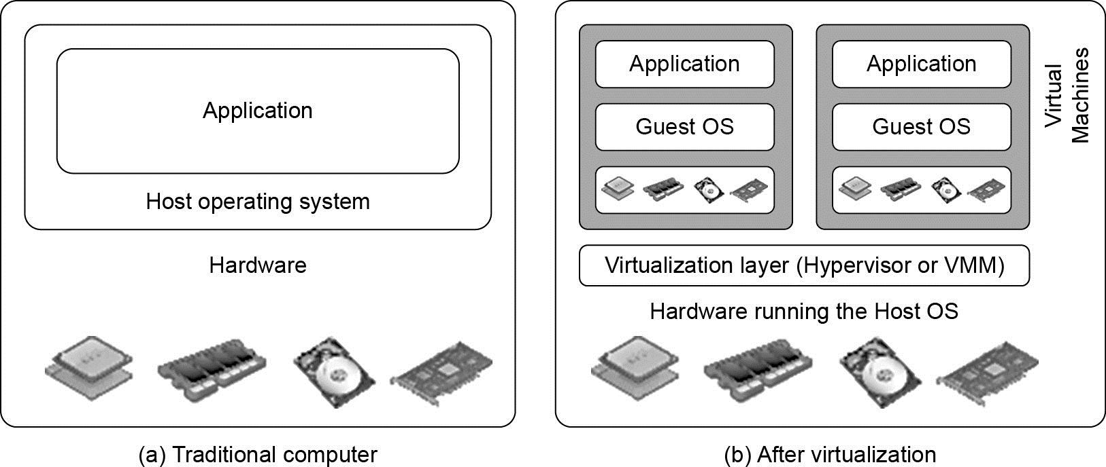

(Courtesy of VMWare, 2008)

Virtual Machine, Guest Operating System,
and VMM (Virtual Machine Monitor) :

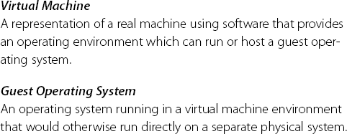

The Virtualization layer is the middleware between the underlying hardware and virtual machines represented in the system, also known as virtual machine monitor (VMM) or hypervisor.
Before Virtualization

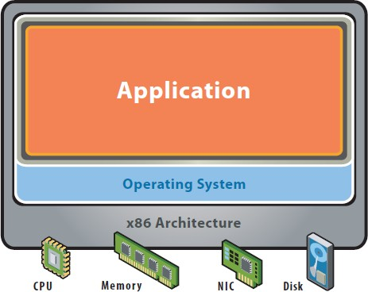
Single OS image per machine
- Software and hardware tightly coupled
- Running multiple applications on same machine often creates conflict
- Inflexible and costly infrastructure
After Virtualization

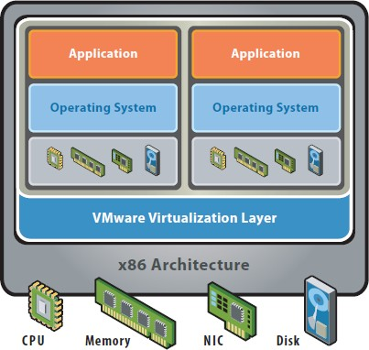
- Hardware-independence of operating system and applications
- Virtual machines can be provisioned to any system
- Can manage OS and application as a single unit by encapsulating them into virtual Machines




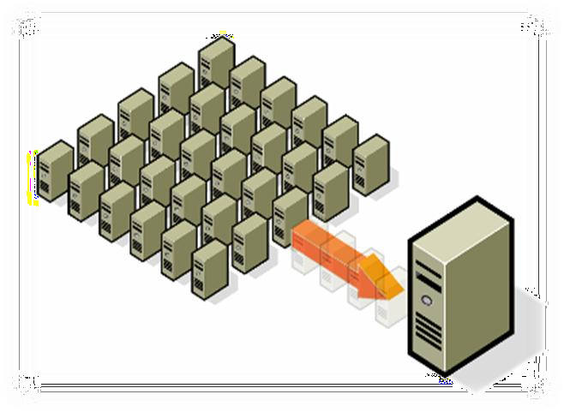
A virtual infrastructure offers the systematic ability to control a complex system consisting of several x86-based servers into several different execution environment
- Consolidation
  - Operate different OS and applications on one single server
  - Support existing applications on a new
hardware
  - Replace the old hardware in the data center
Consolidated :

Dedicated : Running one application on one
physical server
Consolidating multiple applications within the scope of a one OS to reduce number of physical servers

Virtualized :
Running multiple

- Utilize your Existing Servers
  - Realize instantly new projects with virtual infrastructure
  - Postpone new physical hardware purchase

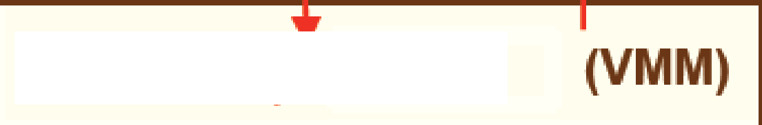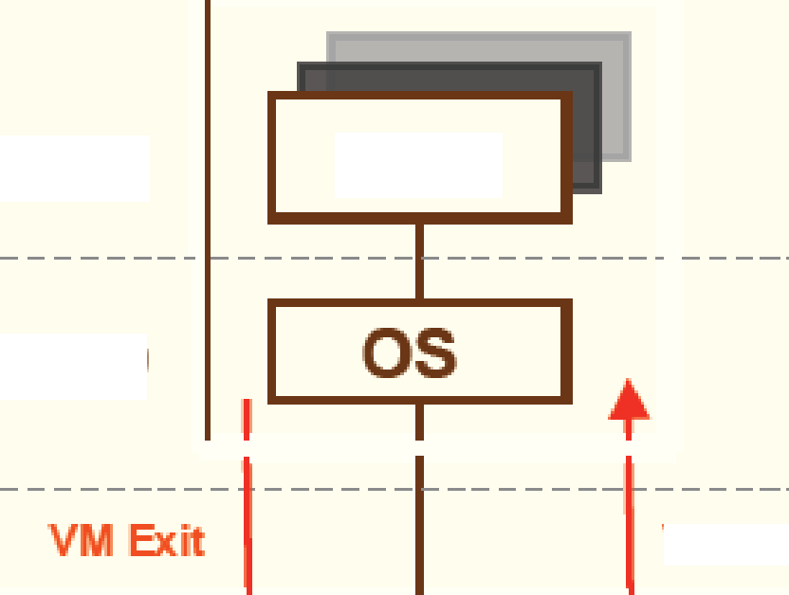
Ring 3
Ring 0
VM Entry

VMWRITE
VMCS

Apps
The VM Control Structure (VMCS)

VM -execution controls | Determines what operatono cause VM exits | CRO, CR3, CR4, Exceptono, IO  Ports, Interrupts, Pin Events, etc.
Guest -state area | Saved on VM exits Reloaded on VM entry | EIP, ESP, EFLAGS, IDTR, Segment  Regs, Exit info, etc.
Host -state are a | Loaded on VM exits | CR3, EIP set to monitor entry point,  EFLAGS hardaded, etc.
VM -exit controls | Determines which sBte to have, load, how to transition | Example: MSR save -load list
VM -entry controls | Determines which state to  load, how to transit on | Ind uding injecting events  (interrupts, exceptions) on entry

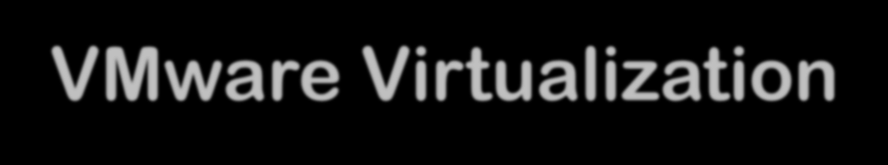
Reduce Energy Costs and Go Green with VMware Virtualization

Reduce the energy demands of your datacenter by dynamic management of computer capacity across a pool of servers.

VMware infrastructure delivers the resources your infrastructure needs and enables you to:

-Reduce energy costs by 80%.
-Power down servers without affecting applications or
users.
-Green your datacenter while decreasing costs and improving service levels.


Key features of the VMware server virtualization

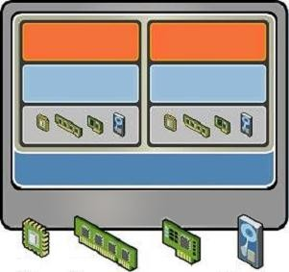
.Partitioning
.Different OS can run on one physical machine
.System resources can be divided between virtual machines

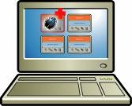
    - Isolation
      - Fault and security isolation on a hardware level
      - Extended resource control for constant performance

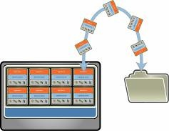
        - Encapsulation
          - Complete status of a virtual machine can be stored in a file
          - Move and copy of a virtual machine is as easy as it is with files
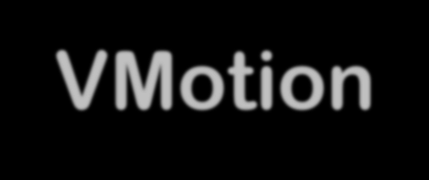
VMware VMotion
- The VMotion technology allows the live migration of virtual machines from one physical server to another and needs therefore no downtime for maintenance activities.
- Move running applications to other servers without disruption. Zero downtime for
hardware maintenance.
- Automates moving virtual machines to other hosts and automates re-balancing after maintenance complete

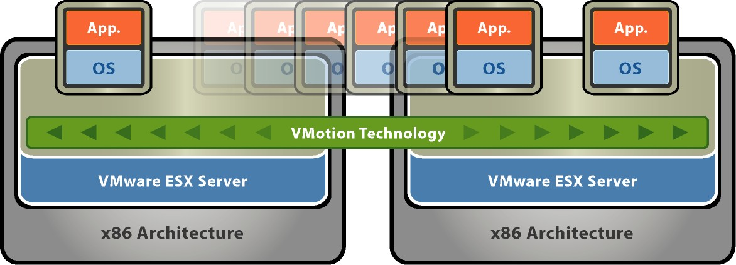

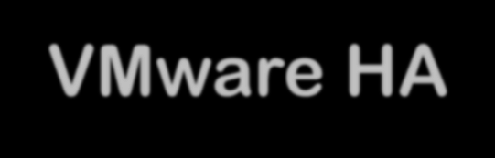
Unplanned Downtime: Server Failure - VMware HA

Simple, Cost effective high availability for all servers


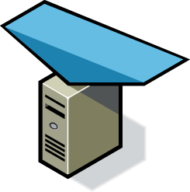
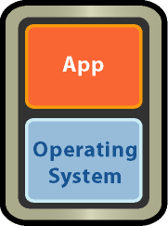
- Automatic restart of virtual machines in case of server failure
X
Resource Pool
- No need for dedicated stand-by hardware
- None of the cost and complexity of clustering

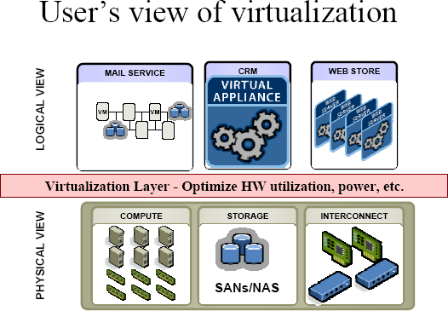

(Courtesy of VMWare, 2008)

Virtualization
Hardware to Applications in Five Abstraction Levels

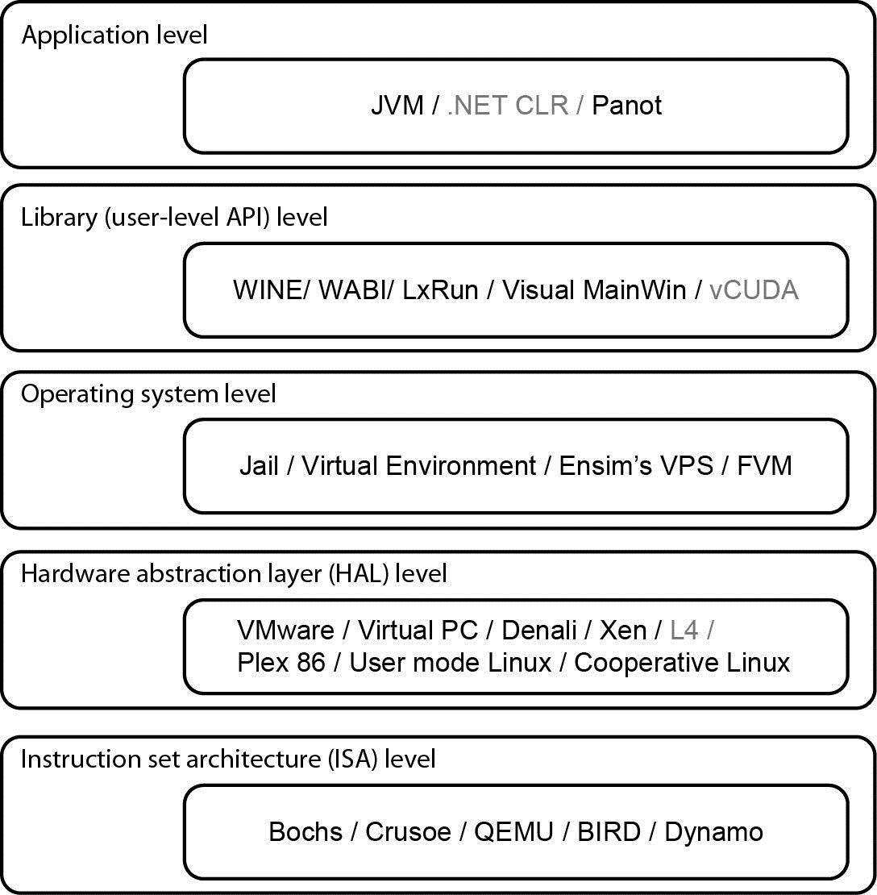
Virtualization at ISA (Instruction Set Architecture) level:
Emulating a given ISA by the ISA of the host machine.
- e.g, MIPS binary code can run on an x-86-based host machine with the help of ISA emulation.
  - Typical systems: Bochs, Crusoe, Quemu, BIRD, Dynamo
Virtualization at Hardware Abstraction level:
Virtualization is performed right on top of the hardware.
- It generates virtual hardware environments for VMs, and manages the underlying hardware through virtualization.
- Typical systems: VMware, Virtual PC, Denali, Xen

Virtualization at Operating System (OS) level:
It is an abstraction layer between traditional OS and user placations.
- This virtualization creates isolated containers on a single physical server and the OS-instance to utilize the hardware and software in datacenters.
- Typical systems: Jail / Virtual Environment / Ensim's VPS / FVM

Virtualization at OS Level
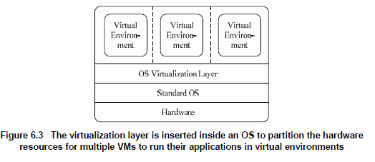
By far, most reported OS-level virtualization systems are Linux-based. Virtualization support on the Windows-based platform is still in the research stage. The Linux kernel offers an abstraction layer to allow software processes to work with and operate on resources without knowing the hardware details. New hardware may need a new Linux kernel to support. Therefore, different Linux platforms use patched kernels to provide special support for extended functionality.
Virtualization for Linux and Windows NT PLATFORM

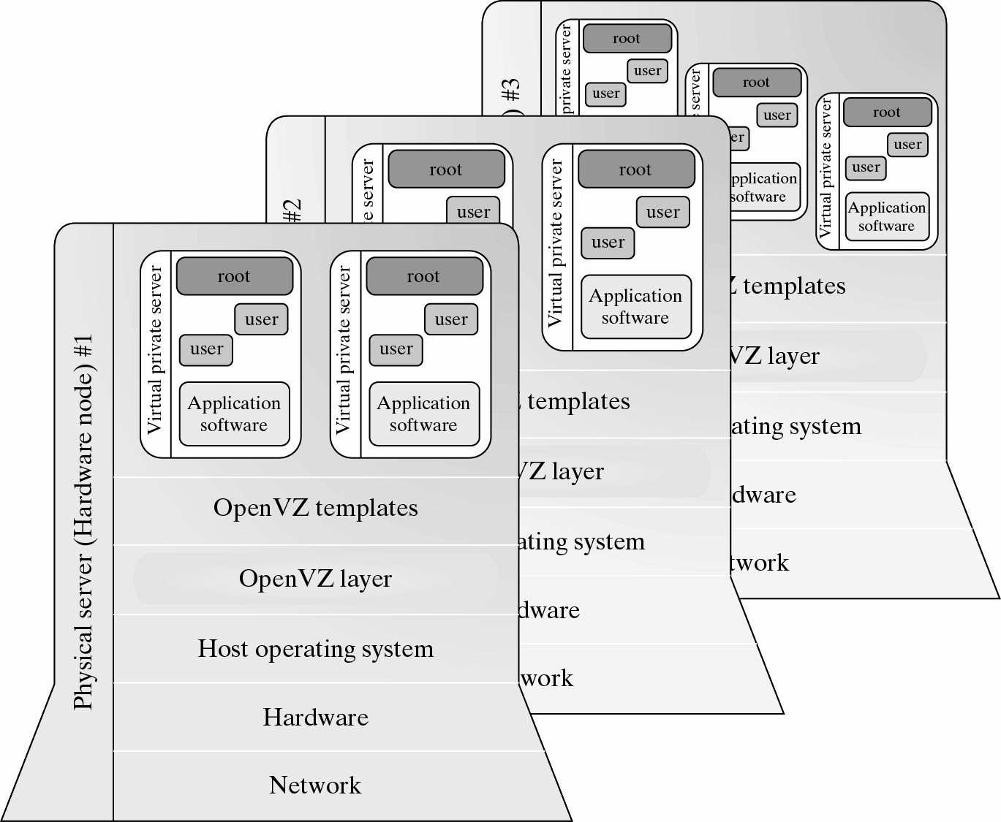

Advantages of OS Extension for Virtualization

- VMs at OS level has minimum startup/shutdown costs

- OS-level VM can easily synchronize with its environment
Disadvantage of OS Extension for Virtualization All VMs in the same OS container must have the same or similar guest OS, which restrict application flexibility of different VMs on the same physical machine.

Library Support level:

It creates execution environments for running alien programs on a platform rather than creating VM to run the entire operating system.
  - It is done by API call interception and remapping.
  - Typical systems: Wine, WAB, LxRun , VisualMainWin
User-Application level:

It virtualizes an application as a virtual machine.
  - This layer sits as an application program on top of an operating system and exports an abstraction of a VM that can run programs written and compiled to a particular abstract machine definition.
  - Typical systems: JVM , NET CLI , Panot

The vCUBE for Virtualization of GPGPU

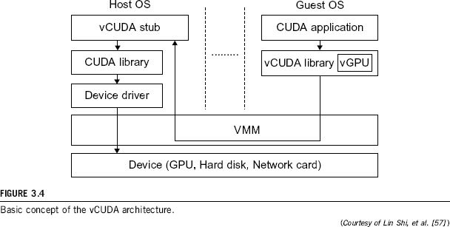
Hypervisor
A hypervisor is a hardware virtualization technique allowing multiple operating systems, called guests to run on a host machine. This is also called the Virtual Machine Monitor (VMM).

Type 1: bare metal hypervisor
- sits on the bare metal computer hardware like the CPU, memory, etc.
- All guest operating systems are a layer above the hypervisor.
- The original CP/CMS hypervisor developed by IBM was of this kind.

Type 2: hosted hypervisor
- Run over a host operating system.
- Hypervisor is the second layer over the hardware.
- Guest operating systems run a layer over the hypervisor.
- The OS is usually unaware of the virtualization

In this architecture, type1 hypervisor or VMM is installed on the bare hardware.
  - VMM communicates directly with system hardware rather than relying on a host operating system.
– E.g: VMWARE ESX, VMWARE ESXi, Microsoft Hyper-V.

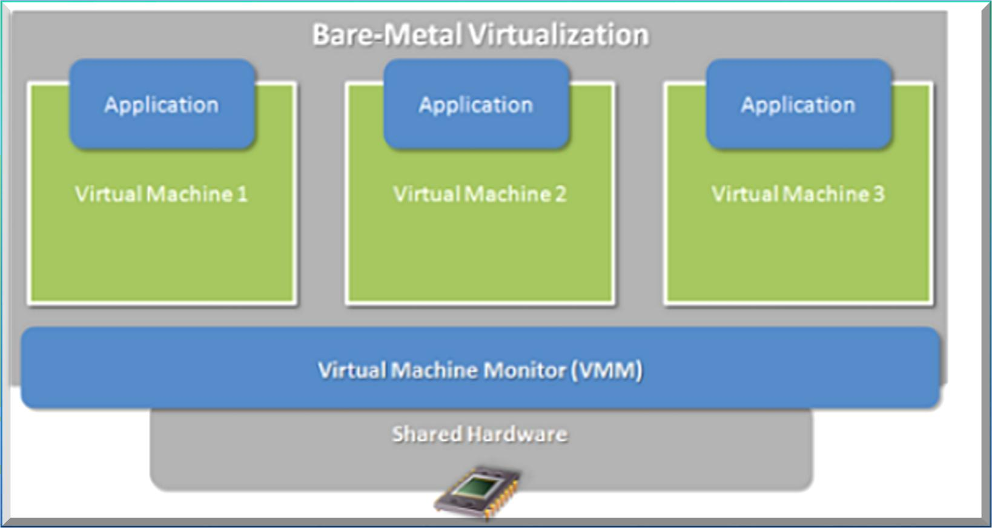

Bare-metal virtual machine monitor is installed directly on system hardware
Bare-Metal Architecture (Pros & Cons)

Advantages

Improved I/O Performance.
  - Support Real Time OS.

- Disadvantage
  - Difficult to install & Configure.
  - Depends upon hardware platform.

- In this architecture, host operating system is first installed.
- A piece of software called a hypervisor or virtual machine monitor (VMM) is installed on top of the host OS.
- It allows users to run various guest operating systems within their own application windows.
- Eg. VMware Workstation, Oracle Virtual Box , Microsoft
Virtual PC.

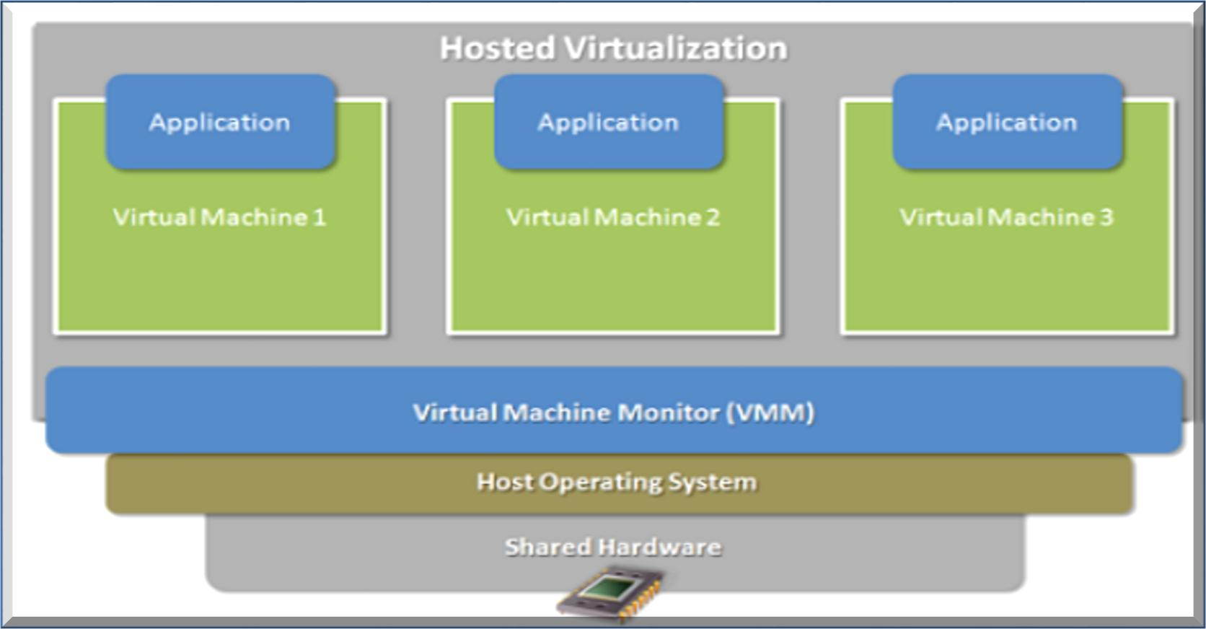

Hosted Virtual Machine Monitor is installed on top of host OS
Hosted Architecture( Pros & Cons)

Advantage

ease of installation and configuration.
  - Unmodified Host OS & Guest OS.
  - run on a wide variety of pc.

- Disadvantage
  - performance degradation.
  - lack of support for real-time operating systems.

Major VMM and Hypervisor Providers

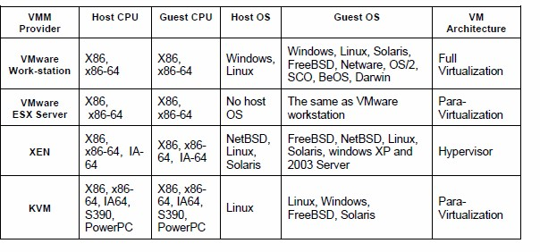
Virtualization Techniques

- Software Virtualization
  - Full Virtualization using binary translation.
  - Para Virtualization or OS assisted Virtualization.

Hardware Assisted Virtualization.
Full Virtualization vs. Para-Virtualization

Full virtualization
- Does not need to modify guest OS, and critical instructions are emulated by software through the use of binary translation.
- VMware Workstation applies full virtualization, which uses binary translation to automatically modify x86 software on-the-fly to replace critical instructions.
- Advantage: no need to modify OS.
- Disadvantage: binary translation slows down the performance.

Para virtualization
- Reduces the overhead, but cost of maintaining a paravirtualized OS is high.
- The improvement depends on the workload.
- Para virtualization must modify guest OS, non-virtualizable instructions are replaced by hypercalls that communicate directly with the hypervisor or VMM.
- Para virtualization is supported by Xen, Denali and VMware ESX.
Full Virtualization

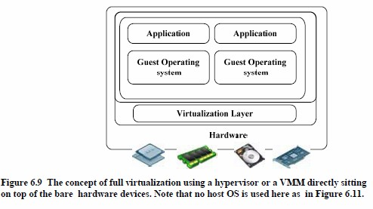

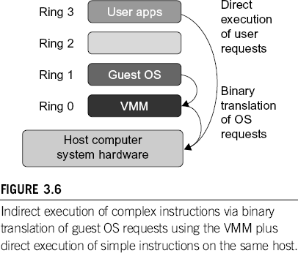
Binary Translation of Guest OS Requests using a VMM:
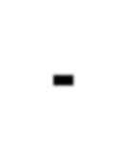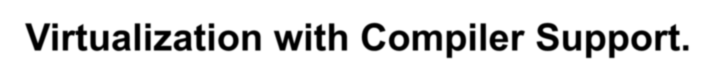
Para- Virtualization with Compiler Support.
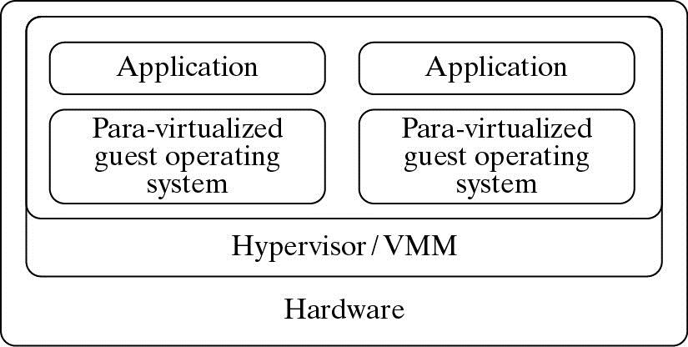

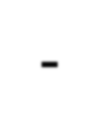
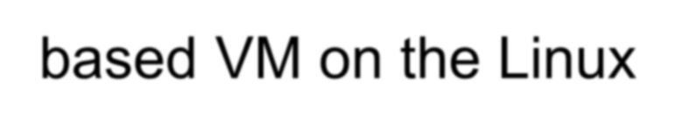
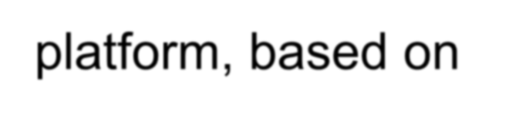
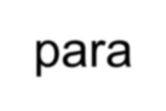
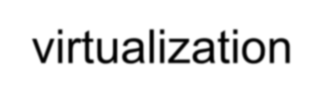
The KVM builds offers kernel-based VM on the Linux platform, based on para-virtualization

Ring 3
Ring 2

Ring 1


Ring 0
Direct axecuéon of user requests

‘Hy{>ercalls’ to the
virtualizaéon layer naplace norwirtualizable OS ins&uctions

FI6URE 3.B
The Use of a paa- vi1 ualized guest OS assisted by an intelligent comjailer to rejalace nonvirtualizable OS inQructâns by hyperca lls.

VMWare ESX Server for Para-Virtualization

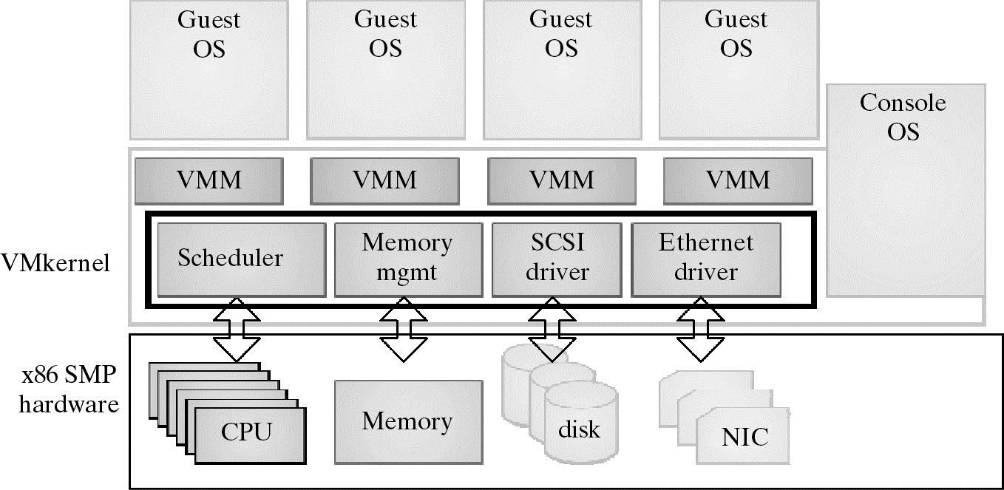

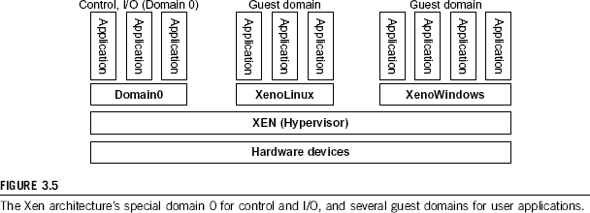

The Linux kernel offers an abstraction layer to allow software processes to work with and operate on resources without knowing the hardware details.

New hardware may need a new Linux kernel to support. Therefore, different Linux plat-forms use patched kernels to provide special support for extended functionality.

The core components of a Xen system are the hypervisor, kernel, and applications.
The organization of the three components is important. Like other virtualization systems, many guest OSes can run on top of the hypervisor.

However, not all guest OSes are mated equal, and one in particular controls the others.
The guest OS, which has control ability, is called Domain 0, and the others are called Domain U. Domain 0 is a privileged guest OS of Xen. It is first loaded when Xen boots without any file system drivers being available. Domain 0 is designed to access hardware directly and manage devices.

Therefore, one of the responsibilities of Domain 0 is to allocate and map hard-ware resources for the guest domains (the Domain U domains).

Domain 0, behaving as a VMM, allows users to create, copy, save, read, modify, share, migrate, and roll back VMs as easily as manipulating a file, which flexibly provides tremendous benefits for users. Unfortunately, it also brings a series of security problems during the software life cycle and data lifetime.

For example, Xen is based on Linux and its security level is C2. Its management VM is named Domain 0, which has the privilege to manage other VMs implemented on the same host. If Domain 0 is compromised, the hacker can control the entire system. So, in the VM system, security policies are needed to improve the security of Domain 0.



Copyright © 2012, Elsevier Inc. All rights reserved. 38
1 - 38

Xen (paravirtualization)
  - Xen is a free open source solution for operating system-level paravirtualization from XenSource. Recall that in paravirtualization the hypervisor and the operating system collaborate on the virtualization, requiring operating system changes but resulting in near native performance.

  - As Xen requires collaboration (modifications to the guest operating system), only those operating systems that are patched can be virtualized over Xen. From the perspective of Linux, which is itself open source, this is a reasonable compromise because the result is better performance than full virtualization. But from the perspective of wide support (such as supporting other non-open source operating systems), it's a clear disadvantage.

  - It is possible to run Windows as a guest on Xen, but only on systems running the Intel Vanderpool or AMD Pacifica. Other operating systems that support Xen include Minix, Plan 9, NetBSD, FreeBSD, and OpenSolaris.

User-mode Linux (UML) allows a Linux operating system to run other Linux operating systems in user- space.
  - Each guest Linux operating system exists within a process of the host Linux operating system. This permits multiple Linux kernels (with their own associated user-spaces) to run within the context of a single Linux kernel.

  - As of the 2.6 Linux kernel, UML resides in the main kernel tree, but it must be enabled and then recompiled for use. These changes provide, among other things, device virtualization. This allows the guest operating systems to share the available physical devices, such as the block devices (floppy, CD- ROM, and file systems, for example), consoles, NIC devices, sound hardware, and others.

  - Note that since the guest kernels run in application space, they must be specially compiled for this use (though they can be different kernel versions).
  - This results in what's called the host kernel (which resides on the hardware) and the guest kernel (which runs in the user space of the host kernel).
  - These kernels can even be nested, allowing a guest kernel to run on another guest kernel that is running on the host kernel.

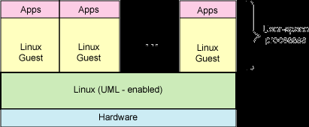
Hardware support for full virtualization
and paravirtualization
  - AMD is also producing hardware-assisted virtualization technology, under the name Pacifica.
  - Among other things, Pacifica maintains a control block for guest operating systems that are saved on execution of special instructions.
  - The VMRUN instruction allows a virtual machine (and its associated guest operating system) to run until the VMM regains control (which is also configurable). The configurability allows the VMM to customize the privileges for each of the guests.
  - Pacifica also amends address translation with host and guest memory management unit (MMU) tables.

  - The most recent news out of Linux is the incorporation of the KVM into the Linux kernel (2.6.20).
  - KVM is a full virtualization solution that is unique in that it turns a Linux kernel into a hypervisor using a kernel module.
  - This module allows other guest operating systems to then run in user-space of the host Linux kernel (see Figure in the next slide).
  - The KVM module in the kernel exposes the virtualized hardware through the /dev/kvm character device.
  - The guest operating system interfaces to the KVM module using a modified QEMU process for PC hardware emulation.

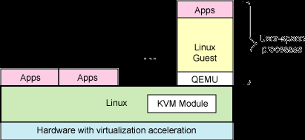

  - The KVM module introduces a new execution mode into the kernel. Where vanilla kernels support kernel mode and user mode, the KVM introduces a guest mode. The guest mode is used to execute all non-I/O guest code, where normal user mode supports I/O for guests.

  - The introduction of the KVM is an interesting evolution of Linux, as it represents the first virtualization technology that is part of the mainline Linux kernel. It exists in the 2.6.20 tree, but can be used as a kernel module for the 2.6.19 kernel. When run on hardware that supports virtualization, Linux (32- and 64-bit) and Windows (32-bit) guests are supported.

lease 2.6.20
nux KERNAL re
Included in Li

Originally developed by Qumranet

GPL v2

48
2

Relies on AMD's AMD-V or Intel's VT-x
virtualization technologies
    - Implemented as kernel modules

– kvm.ko: provides virtualization infrastructure
–

• => Vanilla Linux kernel becomes virtual machine monitor, which can use any kernel infrastructure without modifications
• => KVM virtual machines become regular user- space processes/Bvb

3 © Novell, Inc. All rights 49
Adds “Guest Mode” to Traditional Kernel and User Modes

Guest Userspace
Processes

Kernel)
Guest Kernel
(e.g. Linux

...

Userspace Process

Userspace Process
QEMU-KVM

Linux Kernel
KVM (Module)

Hardware Support, vitualization technologies for x86 (AMD-V/ Intel-VT)

4 © Novell, Inc. All rights
Source: “Virtualization with KVM” training, B1 Systems GmbH 50

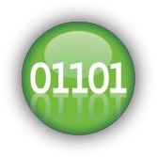
Community project founded in 2003

    - Emulates PC hardware and CPUs

    - Since v 0.10.0 support for KVM VMM

    - Modified qemu-kvm is user space for KVM tool

    - Communication with KVM via /dev/kvm

2 and 64 bit guests (on 64 bit h
osts)
Supports 3

Supports hardware virtualization features
zed drivers
Paravirtuali

Snapshots
es
s of virtualmachin
Delta image

PCI passthrough
epage merging
Kernel sam

ort
Sound supp

CPU, memory and disk over-commit

Live migrat | ion
CPU and device hotplug
nly)
mulation mode o
Non-kvm (e

9 © Novell, Inc. All rights 53


Xen KVM

    - VMM implementation of its own; hypervisor
    - Kernel as I/O dispatcher
and management domain
    - Maintained and supported as a patch to mainline kernel by Novell®
    - Supports fully virtualized and paravirtualized Vms

    - Kernel module

    - Uses kernel as

    - In upstream
kernel

    - Only supports fully

VMM

virtualized VMs

14 © Novell, Inc. All rights 54

Virtualization Examples

Server consolidation - Virtual machines are used to consolidate many physical servers into fewer servers, which in turn host virtual machines. Each physical server is reflected as a virtual machine "guest" residing on a virtual machine host system. This is also known as Physical-to-Virtual or 'P2V' transformation.

  - This undoubtedly where the most change is required by the guest OS
  - Xen challenges the assumption that the OS is the most privileged entity
  - Privileged instructions

– These are paravirtualized by requiring them to be validated/executed within Xen

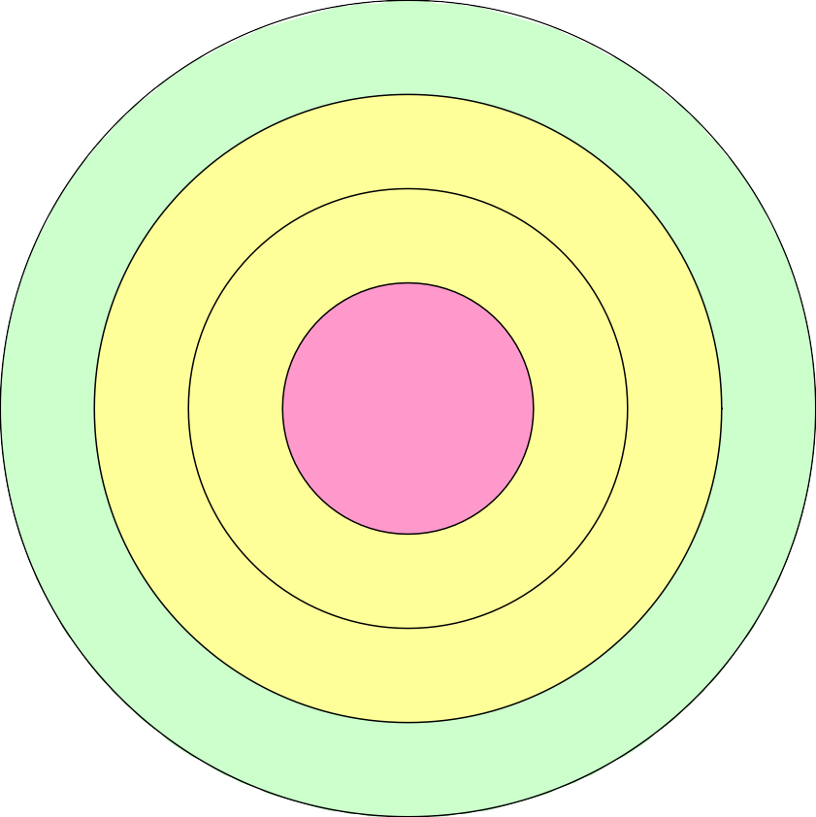
  - The x86 is less difficult than most

Increasing Privilege Level
Ring 0
Ring 1
Ring 2
Ring 3
systems to virtualize
- This is due to the built in security levels build within the x86 (known as rings)
- Most systems have the OS running on ring 0 (the most privileged)
- Most user software runs on ring 3
- Ring 1 & 2 generally are not used
  - Xen uses this fact to modify the OS to execute on ring 1
Virtualization, Scheduling, and Timers

  - Xen currently uses an algorithm called the Borrowed Virtual Time algorithm to schedule domains
  - This is important to mitigate the problem of one domain executing code that can adversely affect another domain.
  - Xen also provides several different types of timers
- Real Time (time that always advances regardless of the executing domain)
- Virtual Time (time that only advances within the context of the domain)
- Wall Clock Time (time that takes in to account local offsets for time zone and DST)

Control transfer & Eventing

Exceptions and Eventing
- These include memory faults and software traps
- These are generally virtualized through Xen’s event handler
- Typically the two most frequent exceptions that occur (enough to effect performance)
  - System Calls
  - Page Faults
- These are two examples of a ‘fast’ handler (one in which bypasses the hypervisor)

Paravirtualization of the MMU

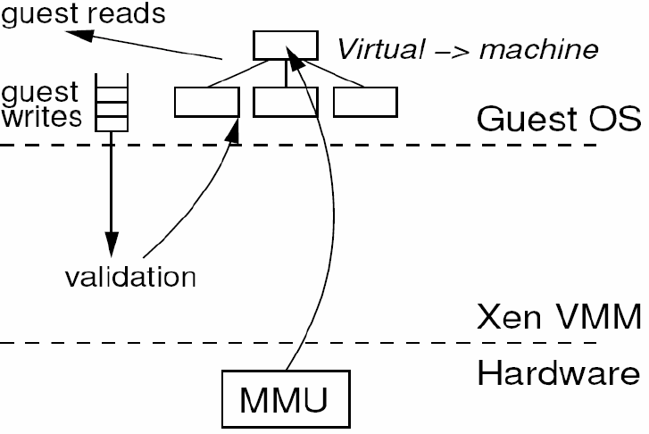
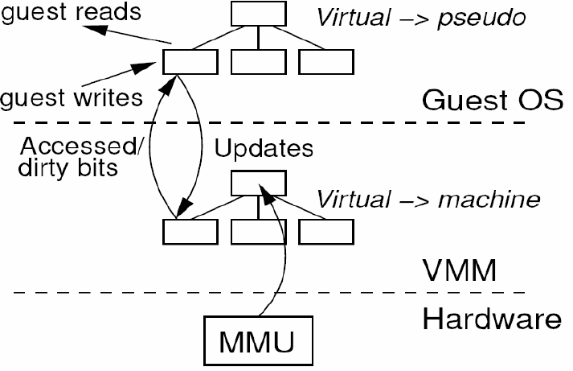

When the guest OS requires a new page table, it allocates it from its own memory reservoir
- After this it is registered with Xen
- The OS then gives up all direct write privleges to the memory
- All subsequent updates must be validated by Xen
- Guest OS’s generally batch these update requests to spread the cost of calling the hypervisor

Segmentation is virtualized in a similar way

  - Xen uses a design where
- Guest OS’s are responsible for allocation and managing hardware pages
- Xen exists in a generally unused section at the top of every address space. This is to ensure that the Xen is never paged out
  - This differs from the approach that Disco takes where the Disco VMM keeps a second level of indirection.
– Essentially VMM within VMM

  - As discussed in an earlier class Memory Management can be quite challenging
  - Some key challenge points
- x86 does not have a software managed TLB
  - Its TLB is not tagged, which means that the TLB must be flushed on a context switch
Xen and Device I/O/ Management

  - Data I/O is transferred to and from domains via Xen through the use of a buffer descriptor ring
- This is a system that is based around a pair of producer consumer pointers, one set used within the guest OS, the other within the Hypervisor
- This allows for the decoupling of when data arrives/is accessed and the event notification

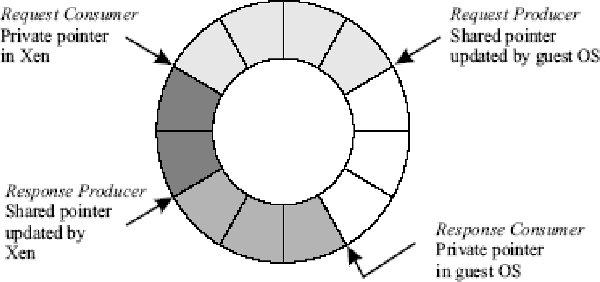

fkq mm q iicue - Tiptur queued by Ac VM but at acccJitctI by Ncn
II ufst a nding ‹kuuripturs - criJfur sits awaiting a rcspu sc Drum Xc















Un itu«t dim:ripu n 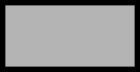

  - Domain0 is given greater access to the hardware (and hypervisor). It has a guest OS running on top of it as well, but also has additional “supervisor” software to manage elements of the other existing domains.
Domain 0
Domain 1
Hypervisor
VM
VM
VM Specific Drivers
VM Specific Drivers
Guest OS
Guest OS
Guest OS on Domain X
Guest OS on Domain 0
Hypervisor Manager
  - This is different than VMWare which has the notion of a Host OS acting underneath it.
Other Drivers
VMWare Drivers
Host Operating System
VMWare

  - Disco acts as the go between for Disk I/O
  - Xen allows Domain0 to have direct access to the disk.
- Domain0 houses virtual block device (VBD) management software
- The VBD makes use of the ring mechanism
- Subsequent domains confine their disk access through the VBD management software
- This allows Xen to maintain a tighter control over disk access, and to allow “batching” of disk requests
  - VMWare (from experience) allows for several options for Disk I/O.
- To allow the guest OS unfettered access to the raw device--basically as a “pass through”
- Allow VMWare to create a “virtual disk” that is a binary file that is contained within the file system of the host OS, and is controlled by the VM Virtual Machine
  - These are also different from running an OS on top of bare hardware, where Disk I/O is managed by the OS

Domain0 is a privileged domain
  - New domain creation is delegated to Domain0

This offers the advantage of reducing the complexity of the hypervisor
- Additionally building new domains that originate from Domain0 allow for a better debug environment

  - Networking and Computers go
hand in hand today
  - Because of this, Xen also provides a “Virtual Firewall”
- Domain0 is responsible for creating the firewall rules (can we see a common theme emerging?)

Internet
- Data is transmitted (and received) using two buffer rings (one for outgoing, the other for incoming data)
Xen’s Virtual Firewall
- Incoming data packets are analyzed by Xen against the Virtual Firewall rules, and if any are broken, the packet is dropped
Guest3
Guest2
Guest1
Guest0

What was observable from the block diagram for Xen was that you still have the notion of Xen enabled hardware drivers
  - This is similar to how VMWare operates.
- For instance if you have a sound card on your machine, the hosting guest machine will detect that you have a Sound Blaster enabled sound card.
- Another example (from VMWare) is the video driver that can be installed on the guest OS to improve video performance.

This is another hidden challenge of virtualization
– Not only do you have to virtualize the memory and CPU, but also any other devices that the guest OS can access!

This paper was presented October 2003. Since then, the popularity of Xen has increased to include support from vendors such as
- Sun Microsystems
- Hewlett-Packard
- Novell
- Red Hat
- Intel
- Advanced Micro Devices
- Voltaire
- IBM

Memory Virtualization Challenges

Address Translation

- Guest OS expects contiguous,
zero-based physical memory

- VMM must preserve this illusion
Page-table Shadowing
- VMM intercepts paging operations

Constructs copy of page tables

Overheads
- VM exits add to execution time
VM

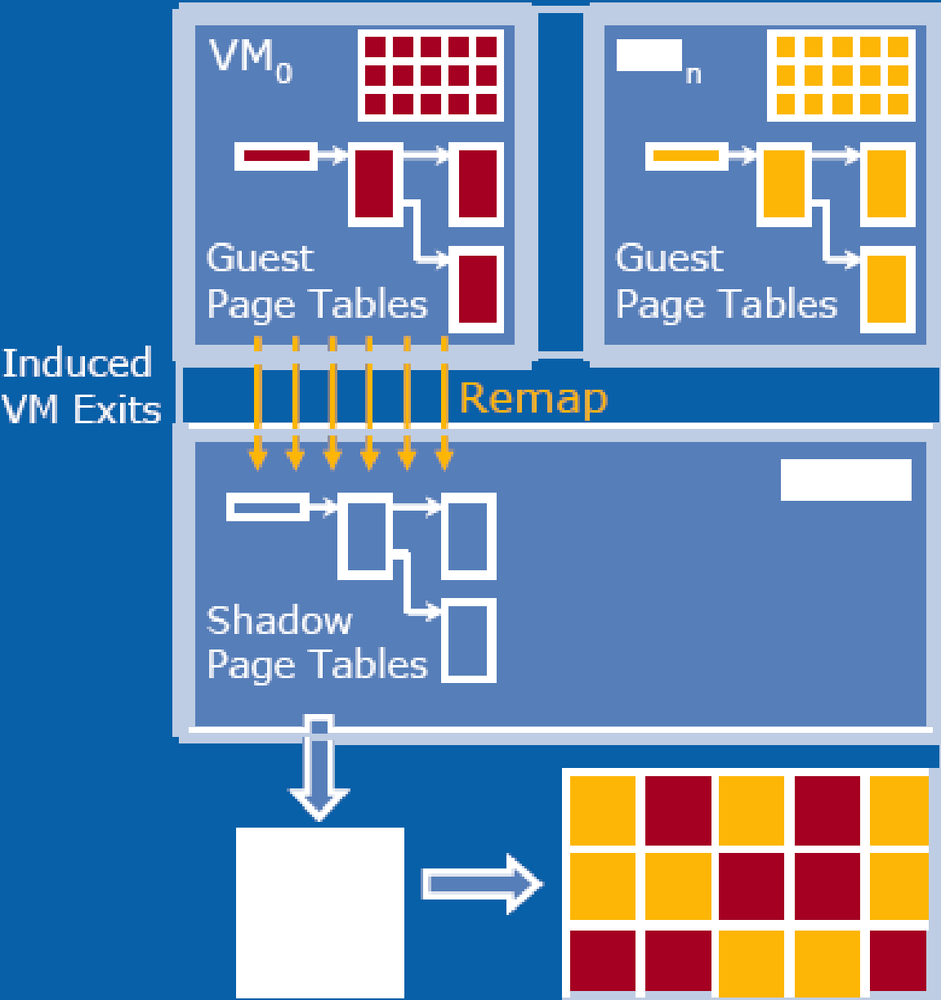
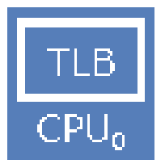
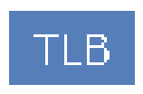
VMM

Shadow page tables consume significant host memory
TLB
CPUo
Memory


Cunent viWal devices
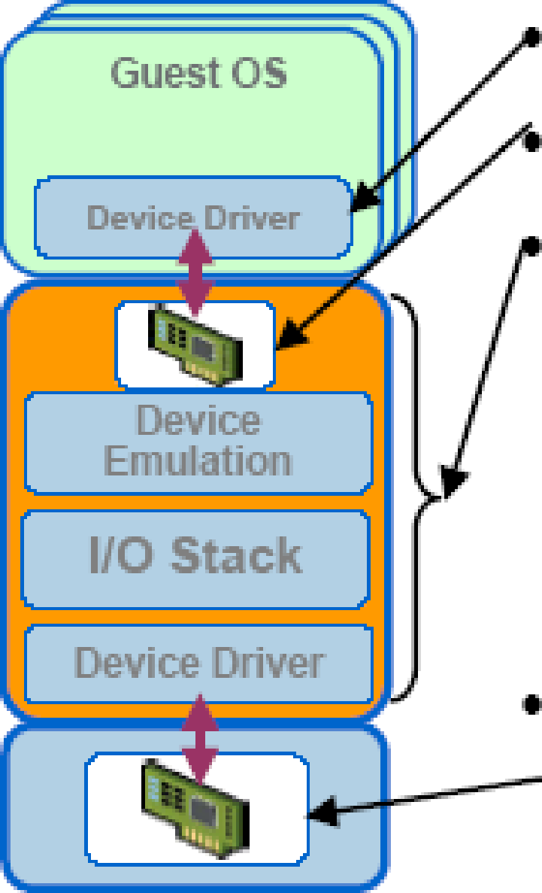
Guest device Aiver Virtual device Virtualization layer
- mnulates the virtual device
- remaps guest and real I/O addresses
- multiplexes and drives the physical device
- VO features, e.g., COW disks,
Real device

- may be different from virtual device

Conclusions on CPU, Memory and I/O Virtualization :
- CPU virtualization demands hardware-assisted traps of sensitive instructions by the VMM
- Memory virtualization demands special hardware support (shadow page tables by VMWare or extended page table by Intel) to help translate virtual address into physical address and machine memory in two stages.
- I/O virtualization is the most difficult one to realize due to the complexity if I/O service routines and the emulation needed between the guest OS and host OS.
Multi-Core Virtualization:

VCPU vs. traditional CPU

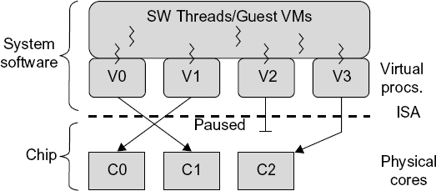

Figure 3.16 Four VCPUs are exposed to the software, only three cores are actually present. VCPUs V0, V1, and V3 have been transparently migrated, while VCPU V2 has been transparently suspended. (Courtesy of Wells, et al., “Dynamic Heterogeneity and the Need for Multicore Virtualization”, ACM SIGOPS Operating Systems Review, ACM Press, 2009 [68] )
Virtual Cores vs. Physical Processor Cores

Physical cores | Virtual cores
The actual physical cores present in the processor. | There can be more virtual cores visible to a single OS than there are physical cores.
More burden on the software to write applications which can run directly on the cores. | Design of software becomes easier as the hardware assists the software in dynamic resource utilization.
Hardware provides no assistance to the software and is hence simpler. | Hardware provides assistance to the software and is hence more complex.
Poor resource management. | Better resource management.
The lowest level of system software has to be modified. | The lowest level of system software need not be modified.

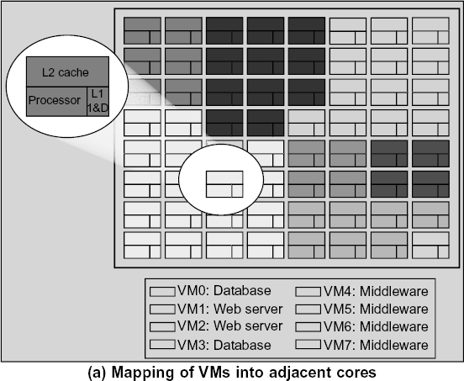

(Courtesy of Marty and Hill, 2007)

Virtual Clusters in Many Cores

Space Sharing of VMs -- Virtual Hierarchy

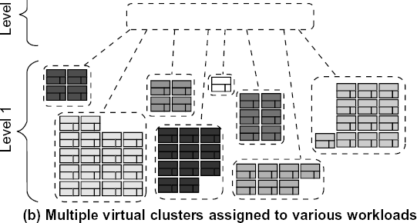
(Courtesy of Marty and Hill, 2007)
Virtual Cluster Characteristics
- The virtual cluster nodes can be either physical or virtual machines. Multiple VMs running with different OSs can be deployed on the same physical node.
- A VM runs with a guest OS, which is often different from the host OS, that manages the
resources in the physical machine, where the VM is implemented.
- The purpose of using VMs is to consolidate multiple functionalities on the same server. This will greatly enhance the server utilization and application flexibility.
- VMs can be colonized (replicated) in multiple servers for the purpose of promoting
distributed parallelism, fault tolerance, and disaster recovery.
- The size (number of nodes) of a virtual cluster can grow or shrink dynamically, similarly to the way an overlay network varies in size in a P2P network.
- The failure of any physical nodes may disable some VMs installed on the failing nodes.
But the failure of VMs will not pull down the host system.

Virtual Clusters vs. Physical Clusters
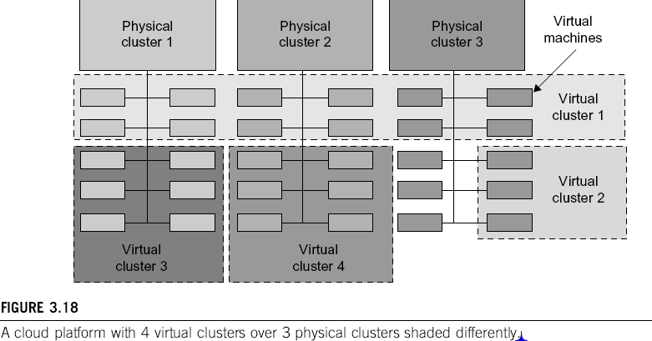

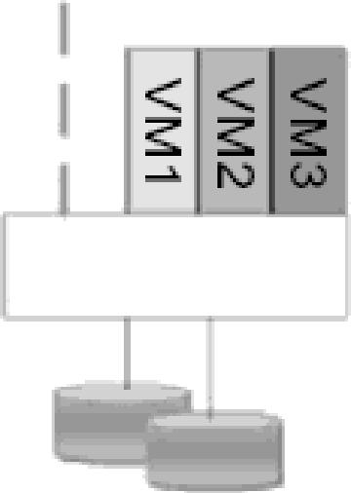
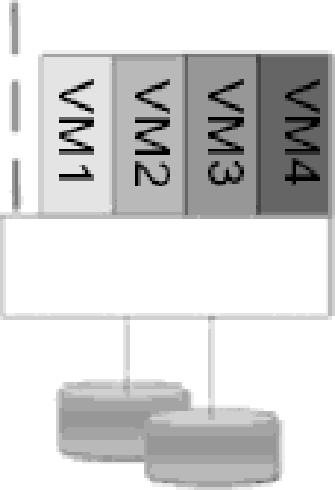
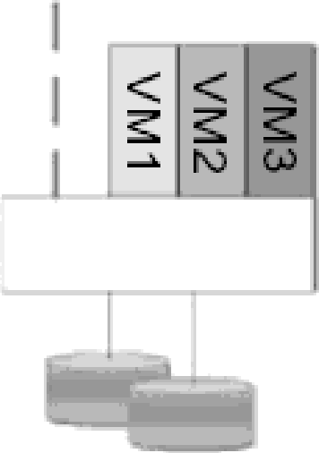
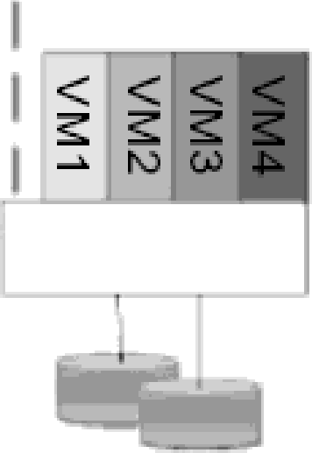
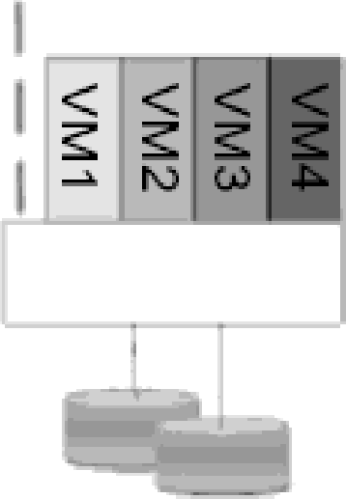
VMM
VMM
VMM
VMM
VMM



FIGURE 3.19
Virtual cluster Virtual cluster Virtual cluster virual cluster



nodes for nodes for nodes foF nodes for , , , application A application B application C application D

The Concept 0f a virtual cluster based 0n dpp!lCdtIo0 d ItIOOIOg.
(Durtes of may, then, Tsi'nghua Uni'verslfy 20

